DRR fora: an example that works

Situation
Effective Disaster Risk Reduction (DRR) requires collective responsibility and coordination across a range of stakeholders, including public and private organisations. Varying functions and responsibilities of agencies mean that often duplicate or uncoordinated activities are implemented. Difficulties are amplified when events such as natural disasters cut across normally well-defined roles, and requires coordinated actions.
While informal discussions across agencies can help coordination, one particularly useful way of planning and coordinating efforts in DRR is through the establishment of a regular dedicated meeting of a range of stakeholders – a DRR forum. An example of a well-functioning DRR forum exists in Agam. In that district, BPBD Agam (Regional Disaster Management Agency) have a close connection with other government agencies, in part because the Bupati (District Mayor) is a strong supporter of the DRR initiatives, but also due to the leadership and inclusive style of the Head of local BPBD. There are numerous occasions - both formal and less formal - that leaders of OPD’s come together to discuss a range of issues and it seems that such regular contact helped to initiate the DRR forum. Taken together, such close contact and similar status across the OPD’s affords meaningful engagement that often involves multi-institutional DRR initiatives. This is seen beyond government agencies because there have been several occasions where public engagement related to DRR has involved more than BPBD (such as Health, Social, Public Works departments), depending on the program.
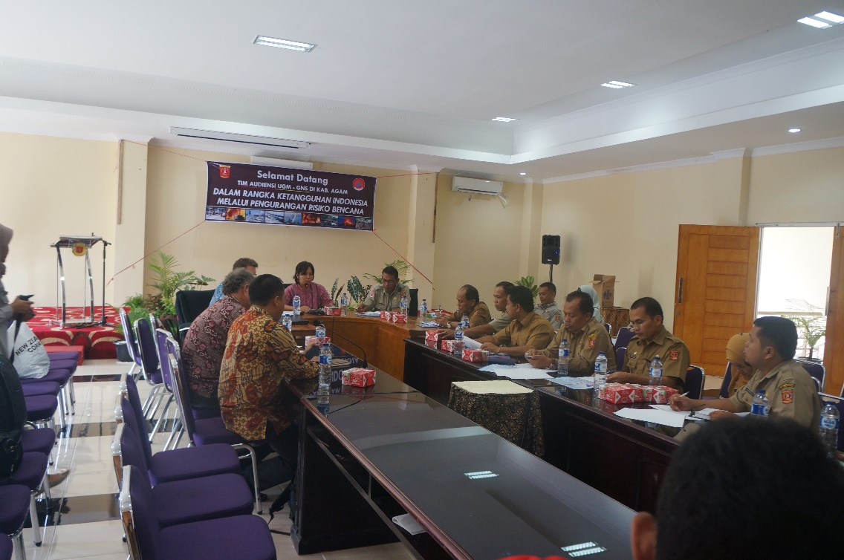
In Agam, meetings that involve many of the OPD’s occur regularly, which enhances cooperation and an effective DRR forum.

Obstacles / Challenges
Currently the engagement between the OPD’s is making for an effective DRR forum in Agam. However, the inclusion of a representative of a local industry (e.g., Palm Oil) would allow for discussions about their worker’s vulnerability, particularly during an earthquake or tsunami. Unfortunately, this has proven difficult to arrange, but there seems to be some potential for private companies to be included in such forum. This challenge exists in most StiRRRD districts, often owing to a poor working relationship between the regional agencies and the private sector.
The Agam DRR forum is conducted at a high level of each government agency and their collective working arrangements appear to be excellent, however, there is some concern that during the next rotation of senior staff, the momentum gained by the forum may be lost. Furthermore, part of the impetus behind the close working relationship in DRR was driven by the Bupati of Agam and this might not be continued by his successor. Hence the main concern in Agam is not their current DRR coordination, but whether they have built the government-wide culture of developing and delivering effective DRR initiatives, augmented by a strong collaboration between OPD’s.

Opportunity/solution
One way in which the DRR forum can continue to flourish is through the considered transition of staff that are rotated in to each OPD. It is hoped that despite staff rotation, the formal and informal discussions will continue, not only at the DRR forum, but more broadly for the efficient collaboration between OPD’s in general. This would ensure that the gains made by this current leadership team continue.
Some of the success that BPBD Agam has achieved is down to the Head of BPBD who was an adept communicator and inclusive personality. Further, he has built significant respect for BPBD through regular public engagement events within schools and other community groups. This has significantly raised the profile of BPBD and will hopefully allow them to recruit both qualified and driven staff members that can continue building on their successes, albeit as a young government department.
In other districts there are difficulties in achieving the same support for a DRR forum – in part because of the lack of respect for BPBD. The Head of BPBD Agam was open to the idea of acting as a mentor of sorts to the other districts and perhaps the cultural similarities between Agam and other parts of West Sumatra will aid in that becoming a reality. Therefore, the experience and successes of Agam could be exported to neighbouring districts via the peer support network initiated in the StIRRRD activity.

